Name : Bari Aniket Prabhakar
Seat No: 704153

Assignment‌ 6 :
- Practical based on implementing all string functions
1.Synatx for ASCII :
select ASCII (character_expression);

Example:

select ASCII ('a');
select ASCII ('P');
select ASCII ('z');
select ASCII ('D');
select ASCII ('A');

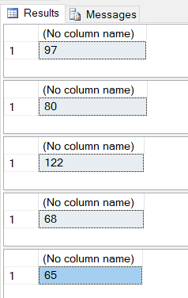

2.Synatx for Char :
Select CHAR(Integer_expression);

Example:
select CHAR(65);
select CHAR(78);
select CHAR(73);
select CHAR(75);
select CHAR(69);
select CHAR(84);

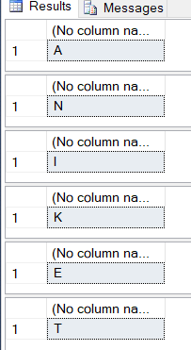

3.Synatx for Difference:
DIFFERENCE(Character_expression,character_expression);

Example:
select SOUNDEX ('praveen'), SOUNDEX('pravin');
select DIFFERENCE ('praveen' , 'pravin');

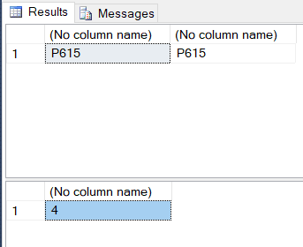

4.Synatx for Lower and Upper:
select LOWER(Character_expression)
select UPPER(Character_expression)

Example:
select LOWER('NINAD WANI');

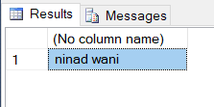

select UPPER('pranav dubey')

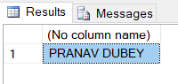

5.Synatx for LTRIM and RTRIM:
LTRIM ( character_expression )
RTRIM ( character_expression )

Example:
select LTRIM (' paresh chaudhari' )

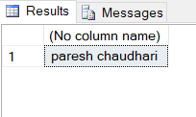
select RTRIM ( 'Ninad Wani ' )

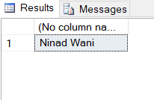

6.Synatx for Reverse and Left:
REVERSE (character_expression)
LEFT (character_expression,integer_expression)

Example:
select REVERSE( 'Aniket');
select LEFT('Paven' , 4);

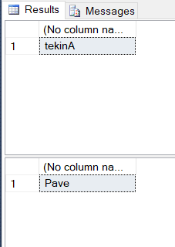

7.Synatx for Substring:
SUBSTRING ( expression , start , length);

Example:
select SUBSTRING('Maharashtra',1,4);

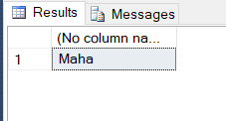

3.Synatx for Difference:
Example:

Assignment‌ 7 :
- Practical based on implementing Date and Time functions
Date and Time:
select
CURRENT_TIMESTAMP AS 'current time',
SYSDATETIME() AS 'system date time';

select
YEAR('2021/02/05 15:43:58') AS year,
MONTH('2021/02/05 15:43:58') AS month,
DAY('2021/02/05 15:43:58') AS day;

select
DATEPART(YEAR, '2021/02/05 15:43:58')AS year,
DATEPART(MONTH, '2021/02/05 15:43:58')AS month,
DATEPART(DAY, '2021/02/05 15:43:58')AS day,
DATEPART(HOUR, '2021/02/05 15:43:58')AS hour,
DATEPART(MINUTE, '2021/02/05 15:43:58')AS minute,
DATEPART(SECOND, '2021/02/05 15:43:58')AS second;

select
DATENAME(YEAR, '2021/02/05 15:43:58')AS year,
DATENAME(MONTH, '2021/02/05 15:43:58')AS month,
DATENAME(DAY, '2021/02/05 15:43:58')AS day,
DATENAME(HOUR, '2021/02/05 15:43:58')AS hour,
DATENAME(MINUTE, '2021/02/05 15:43:58')AS minute,
DATENAME(SECOND, '2021/02/05 15:43:58')AS second;

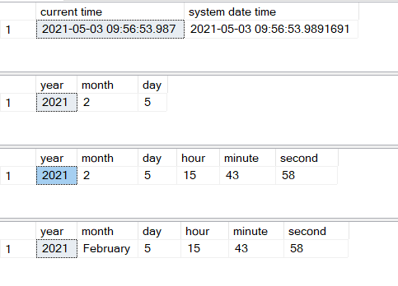
Create Date or Modify or combines Dates:
select DATEFROMPARTS(2020,05,25) AS date;
select DATEADD(DAY, -14, '2021-05-21') AS date_add;
select DATEDIFF(DAY,'2021-05-21', '2021-06-02')AS date_difference;

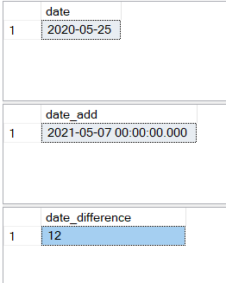
GETDATE() and SYSDATETIME() :
select GETUTCDATE() AS _GETUTCDATE;
select SYSUTCDATETIME() AS _SYSUTCDATETIME;
select SYSDATETIMEOFFSET() AS_SYSDATETIMEOFFSET;

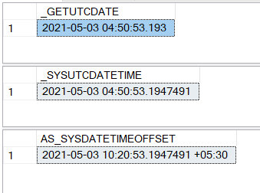
E-month() :
select EOMONTH('2020-02-03') as _eom;

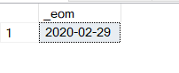

Assignment‌ 8 :
- Practical based on implementing union and intersection

Syntax:
UNION :
Syntax :
SELECT column_name(s)
FROM table1 UNION
SELECT column_name(s) FROM table2;
INTERSECTION :
Syntax :
SELECT column_name(s)
FROM table1 INTERSECT
SELECT column_name(s) FROM table2

Example :

Table A :
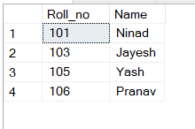

Table B:
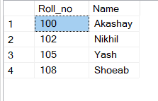
UNION Set operator SQL Query
select *from stud_A
union
select *from stud_B

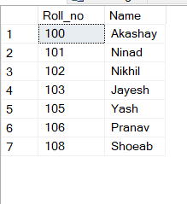

INTERSECT set operator Query :
select *from stud_A
intersect
select *from stud_B

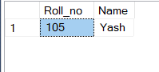

Assignment‌ 9 :
- Demonstrate various joins in SQL
Syntax:
1 . INNER JOIN:
Syntax :
SELECT table 1.column1, table 2.column 2…
FROM table1
INNER JOIN table2
ON table 1.common_field=table 2.common_field
2 . CROSS JOIN :
Syntax :
SELECT table 1.column 1,table 2.column 2….
FROM table 1,table1
3 . SELF JOIN :
Syntax :
SELECT a.column_name,b. column_name…..
FROM table 1 a,table 1 b
WHERE a.column_field = b.comman_field ;

Example :

CREATE TABLE CORDER
(
ORDER_ID INT ,
CUST_ID INT,
ORDER_NM VARCHAR(20),
ORDER_DATE INT,
);

INSERT INTO CORDER VALUES (1,101,'Xiaomi',14);
INSERT INTO CORDER VALUES (2,102,'Samsung',15);
INSERT INTO CORDER VALUES (3 ,103,'Mi',17);

SELECT * FROM CORDER;
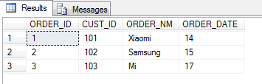

CREATE TABLE CUST
(
CUST_ID INT ,
CUST_NM VARCHAR(20),
CUST_CITY VARCHAR(40),
CUST_SID INT,
);
INSERT INTO CUST VALUES (105,'Pranav','PUNE',151);
INSERT INTO CUST VALUES (102,'Yash','MUMBAI',152);
INSERT INTO CUST VALUES (103,'Ninad','NASHIK',163);
SELECT * FROM CUST;

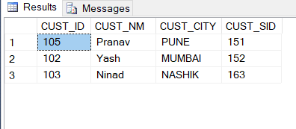

INNER Join :
SELECT CORDER.ORDER_NM,CUST.CUST_NM
FROM CORDER
INNER JOIN CUST
ON CORDER.CUST_ID = CUST.CUST_ID;

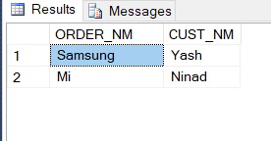

CROSS Join :
SELECT CORDER.CUST_ID,CORDER.ORDER_DATE,CUST.CUST_CITY
FROM CORDER
CROSS JOIN CUST;

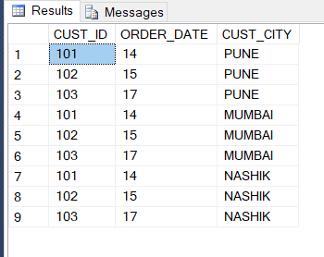
SELF Join :
SELECT a.ORDER_ID,b.CUST_CITY
FROM CORDER a,CUST b
WHERE a.CUST_ID=b.CUST_ID

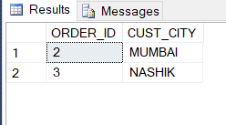
RIGHT Join :
SELECT CUST.CUST_NM,CUST.CUST_ID,CUST.CUST_SID,CORDER.ORDER_NM
FROM CORDER
RIGHT JOIN CUST
ON CORDER.CUST_ID=CUST.CUST_ID

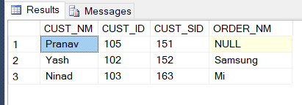
LEFT Join :
SELECT CORDER.CUST_ID,CORDER.ORDER_NM,CORDER.ORDER_DATE,CUST.CUST_NM
FROM CUST
LEFT JOIN CORDER
ON CORDER.CUST_ID=CUST.CUST_ID
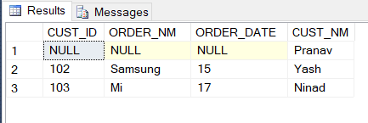

Assignment‌ 10 :
- Practical based on performing different operations on view
Syntax :
CREATE VIEW “view_name”
AS “sql statements”
Example :
create table empDetails
(
emp_id int,
emp_name varchar(20),
emp_age int,
emp_addr varchar(20),
emp_sal money
);
insert into empDetails values(1,'Ramesh',24,'mumbai',2000);
insert into empDetails values(2,'Suresh',35,'Delhi',1500);
insert into empDetails values(3,'Khilesh',22,'Nashik',2000);
insert into empDetails values(4,'Jayesh',27,'Jalgaon',6500);
insert into empDetails values(5,'Madhav',28,'Dhule',8500);
insert into empDetails values(6,'Sundar',22,'Pune',10000);

select *from empDetails;

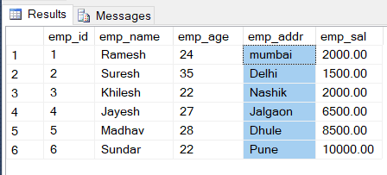
Create View :
create view v1
as
select emp_name, emp_age
from empDetails
where emp_age=22;

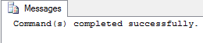
select *from v1;

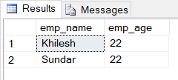

Alter View :
alter view v1
as
select emp_name, emp_age , emp_addr,emp_sal
from empDetails;

select *from v1;

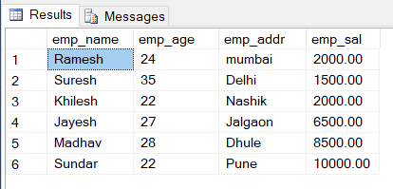
select emp_age,emp_name
from empDetails
order by emp_name;

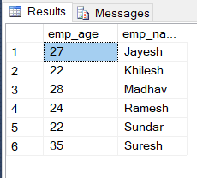

Drop View :
Drop view v1;

Assignment‌ 11 :
- Practical based on performing different operations on view
Syntax :
CREATE PROCEDURE procedure_name
BEGIN
//statements;
END
Example :
create table emp_information
(
emp_id int,
emp_nm varchar(20),
emp_post varchar(20),
emp_sal int
);
insert into emp_information values(101,'Ninad','engineear',2100);
insert into emp_information values(102,'Pranav','tester',1900);
insert into emp_information values(103,'Yash','anyalist',3300);
insert into emp_information values(104,'Vishal','manager',2500);

select *from emp_information;

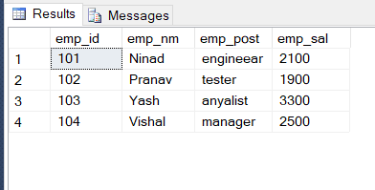
create procedure emp_info @id int
as
declare @sal_new int
set @sal_new=53000
begin
update emp_information set emp_sal=@sal_new
where emp_id=@id
end

execute emp_info 103;

select *from emp_information;

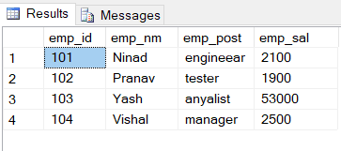

create procedure calculate_pf
as
declare @pf decimal(10,2)
declare @pftx decimal (10,2)
set @pf=0.15
set @pftx=0.05
begin
select emp_id,emp_nm,emp_post,emp_sal,emp_sal*@pf,emp_sal*@pftx
from emp_information
end
execute calculate_pf;

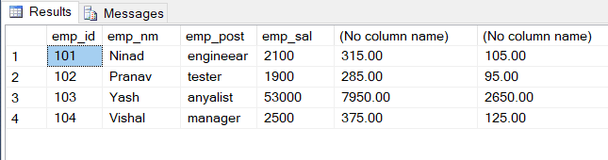

drop procedure calculate_pf

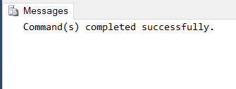

Assignment‌ 12 :
- Practical based on implementing use of Triggers
TRIGGER:
Syntax :
CREATE TRIGGER < TRIGGER _NAME >
ON DATABASE
FOR CREATE _TABLE, ALTER_TABLE AS
BEGIN <TRIGGER_BODY>
END
create table Stud1
(
Roll_no int,
Name varchar(20),
Address varchar(20)
);

create trigger trig
on Stud1
after
insert
as
update Stud1
set Name= UPPER(Name)
go

insert into Stud1 values(1,'Ninad Wani','Jalgaon');

select * from Stud1

